CPE301 – SPRING 2019

Design Assignment DA1B

Student Name: Itzel Becerril

Student #:2000478001

Student Email: becerri2@unlv.nevada.edu

Primary Github address: HadidBuilds/hw_sub_da1

Directory:DA1B

1. **COMPONENTS LIST AND CONNECTION BLOCK DIAGRAM w/ PINS**

Atmel Studio was used.

1. **INITIAL/MODIFIED/DEVELOPED CODE OF TASK 1/A**

I started from scratch.

1. **DEVELOPED MODIFIED CODE OF TASK 2/A from TASK 1/A**
2. ;
3. ; DA1B.asm
4. ;
5. ; Created: 2/21/2019 5:50:59 PM
6. ; Author : becerri2
7. ;
8. ; Replace with your application code
9. .equ STARTADDS = 0x0200 ;starting address
10. .org 0
11. CLR R0 ;clearing r0 register
12. LDI XL, low(STARTADDS) ;XL = STARTADDS[7:0]
13. LDI XH, high(STARTADDS);XH = STARTADDS[15:8]
14. LDI YL, low(0X0400) ;YL=0x00
15. LDI YH, high(0X0400);YH=0x04
16. LDI ZL, low(0X0600);ZL = 0x00
17. LDI ZH, high(0X0600);ZH = 0x06
18. LDI R24,0 ;R24 = 0 for addc later
19. LDI R22, 3 ;R22 = 3
20. LDI R20, 99 ;R20 = 99
21. LDI R21, 10 ;R21 = 10
22. START:
24. INC R21 ;R21 = R21 + 1 used to inc num to populate X
25. ST X+, R21 ;[X] = R3
26. MOV R23, R21 ;R23 = R21
27. JMP CHECK ;jump to check divisible by 3
29. CONTINUE:
30. DEC R20 ;R20 = R20 - 1
31. BRNE START ; if not equal to 0 continue to get next num in start
32. JMP DONE ;jump to done
33. CHECK:
34. SUBI R23, 0X03 ;subtract 3 from num R23
35. BRLT NOTDIV ;if less then 0 then go to not divisible
36. CPI R23, 0 ;compare R23 to 0
37. BRNE CHECK ;if equal not equal to 0 continue to sub
38. JMP ISDIV ;jump to divisible
39. ISDIV:
40. ST Y+, R21 ;[Y] = R21
41. ADD R16, R21 ; R16 = R16 + R21
42. ADC R17, R24 ; R17 = R17 + R24 + carry
43. JMP CONTINUE ; jump to continue
44. NOTDIV:
45. ST Z+, R21 ; [z] = R21
46. ADD R18, R21 ; R18 = R18 + R21
47. ADC R19, R24 ; R19 = R19 + R24 + carry
48. JMP CONTINUE ; jump to contiue
49. DONE:
50. BREAK
51. **SCHEMATICS**

None

1. **SCREENSHOTS OF EACH TASK OUTPUT (ATMEL STUDIO OUTPUT)**

Task 1: Filling up X with 99 numbers between 10 and 255

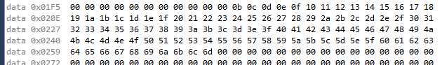

Task 2: Filling in Y with numbers divisible by 3

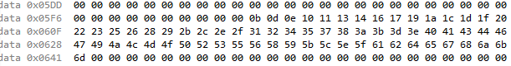

Filling in Z with numbers not divisible by 3



Task 3 & 5: Frequency set at 16 MHz

R16:R17 = BC:07 = 1980

R18:R19 = 78:0F = 3960

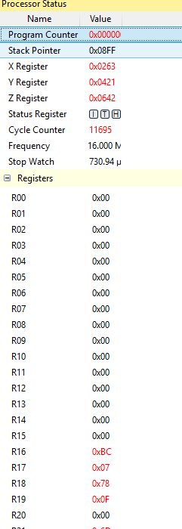

Task 4: Verification using C++ code

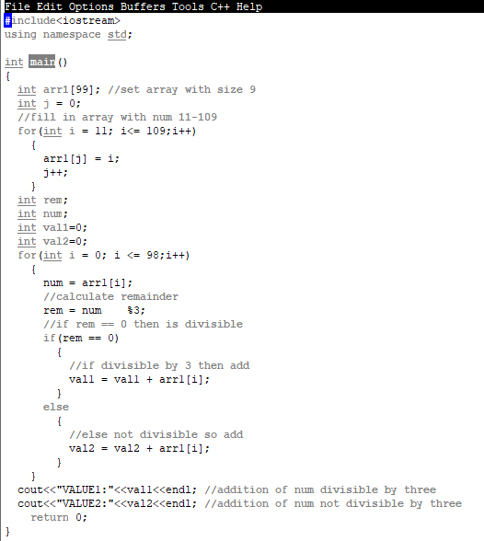

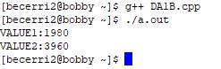

1. **SCREENSHOT OF EACH DEMO (BOARD SETUP)**

No board setup

1. **VIDEO LINKS OF EACH DEMO**

No Video

1. **GITHUB LINK OF THIS DA**

https://github.com/HadidBuilds/hw_sub_da1

**Student Academic Misconduct Policy**

<http://studentconduct.unlv.edu/misconduct/policy.html>

“This assignment submission is my own, original work”.

Itzel Becerril